June 26, 2025

Dear Hiring Manager:

It is with great excitement and interest that I am submitting this cover letter as a part of my application for the Business, Marketing, and G&A Internship with Apple. I learned about this internship through some of my connections at Apple, who spoke highly of the opportunities and experience that Apple offers for students eager to strengthen their technical skills and contribute to impactful, real-world projects. After reviewing this internship in more detail, I found that the role aligns with my technical skills of being knowledgeable in programming topics, while also having business/finance experience. Furthermore, this position aligns with my professional goals of working in a role where I’m able to utilize both my programming knowledge and my capabilities in business. It will allow me to utilize the knowledge I already have to develop innovative and creative solutions, as well as build on my knowledge and provide real-world experience.

As a Computer Science major with a minor in business, I’ve built a foundation of programming knowledge through courses such as Software Development and Systems Programming, and was able to apply it

In addition, my position as an intern at Oversight has improved my technical, analytical, and interpersonal skills, which are some of the abilities that will help me succeed in this position. In this role, I collaborate with multiple teams within the company to optimize the product, utilizing concepts such as software development in Java and Python to build and enhance the AI system, as well as scripting to streamline mundane tasks and do automation-related tasks. Furthermore, I engage with clients in order to obtain feedback on our product, implementing their feedback into development, improving customer satisfaction and functionality of the product.

If given the opportunity, with my skills, curiosity, and drive for continuous improvement, I am confident I can exceed your expectations in this position. Thank you for your time and consideration. If you require any additional information or would like to speak with me further about my qualifications, please contact me by phone at (678)-564-8851 or by email at cullenowens2005@gmail.com. I look forward to meeting with you soon!

Sincerely,

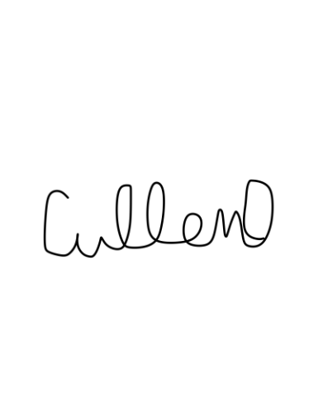

Cullen Owens

